**­Merchant Support:**

Merchant Support Dashboard

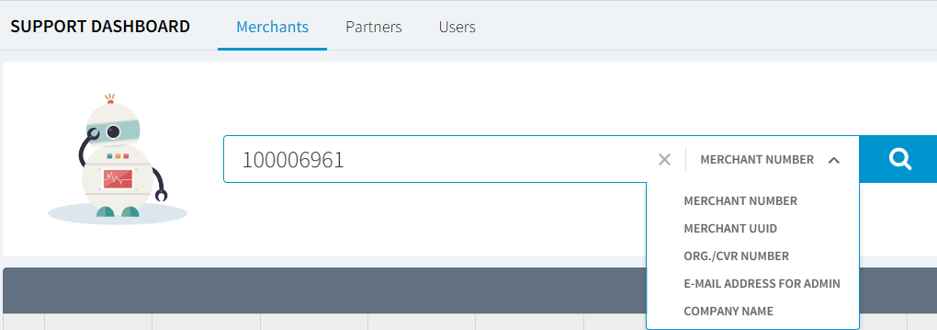

1. Merchants can be search by above options shown in the given dashboard screen.
2. If support user does not have details of the merchant, then user can use * in the search box which will retrieve the list of all merchant.
3. The filtered data can be sorted based on merchant number, merchant uuid, etc. Support team can manipulate merchant details as per requirement.
4. Support team can view the dashboard of merchant where support user can go seepay out amount, sales, payment method, total sales volume, average value and latest order report with respective today, week and month.

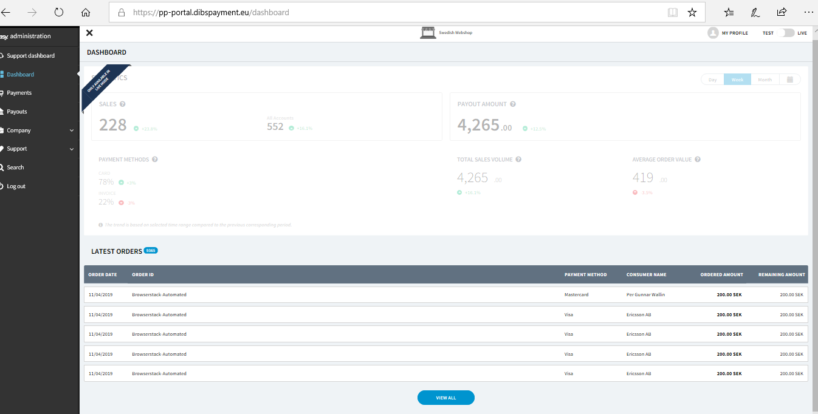

**Partners Support:**

Partners are those who are selling their products along with creating more merchants under dibs.

There are two types of partner –

(1) Partner Manager

(2)Partner Support

**Partner Manager Flow –**

Partner Manager

List Of Users

CreatePartner

Form Filling

Quick Action

Edit Partner

Manage Merchant

Setting

Prise Packing

Contact Person

Company Info

Submit

Mail Triggered

1. Partner Manager can add/disable merchants.Individual partners can create multiple merchants.
2. When partner manager edits partner details and submits then email notification triggered to partner and status remain pending until partner accept that request.
3. There is “Manage Merchant”option for each partner row under partner manager result list by which partner manager can manage the merchants and track status of merchant whether it is LIVE/Pendingor send useractivation link if it shows status as pending. Please refer the below image for overview.
4. In order to creating partner, partner manager has to fill all information like Company info, Contact person, price package and settings.

**Partner Support –**

1. Support Team can view all the existing partner details on Partners tab.
2. Partners cannot have merchants which are already assigned to other partners.

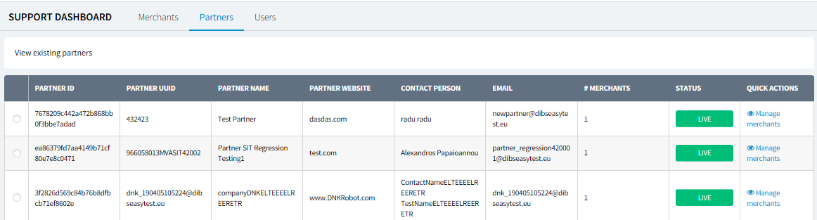

Note: In Partner there is no search and sorting functionality.

**User Support:**

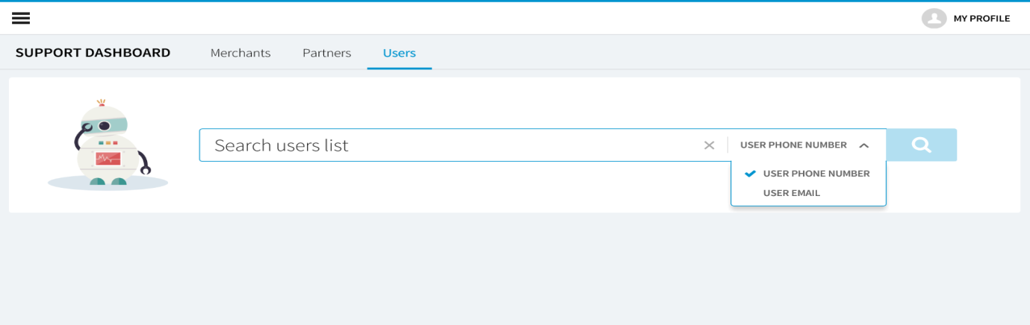

1. User can be search by above options shown in the above screenshot.
2. If support user does not have details of the user, user needs to use * in the search box which will retrieve all users.
3. The filtered data can be sorted based on name, phone number of users. Support user can reorder table columns based on preferences.